GUJARAT TECHNOLOGICAL UNIVERSITY


CHANDKHEDA, AHMEDABAD AFFILIATED

NEW LJ INSTITUTE OF ENGINEERING AND TECHNOLOGY BODAKDEV, AHMEDABAD

A PROJECT REPORT ON
NextGen Furnishings & Digital Store

UNDER SUBJECT OF
DESIGN ENGINEERING – 2A (3150001)
SEMESTER – V (CSE)

SUBMITTED BY:

NAME OF STUDENT | ENROLLMENT NO.
PATEL HET ASHOKKUMAR | 221430131075
SHETH ANAND AJAYKUMAR | 221430131111
PATEL NEEL MUKUNDLAL | 221430131081
PATEL BHAGYA NITINKUMAR | 221430131073
VEDANT MUKESHKUMAR SHAH | 221430131133

Prof. Asiya Durani  Department of (CSE) | Dr. Gayatri S. Pandi  Head Of the Department (CSE)

ACADEMIC YEAR
(2024-2025)

NEW L. J. INSTITUTE OF ENGINEERING AND TECHNOLOGY
DEPARTMENT OF (CSE)
[2024-2025]



Certificate

This is to certify that the project entitled “NEXTGEN FURNISHINGS & DIGITAL STORE” has been successfully carried out by PATEL HET ASHOKKUMAR (221430131075), PATEL BHAGYANITINKUMAR(221430131073), PATEL NEEL MUKUNDLAL (221430131081SHETH ANAND AJAYKUMAR(221430131111), VEDANT MUKESHKUMAR SHAH(221430131133) under my guidance in partial fulfilment of the requirements for the degree of Bachelor of Engineering in Computer Science and Engineering (Artificial Intelligence and Machine Learning), 5th Semester, New L. J. Institute of Engineering and Technology, during the academic year 2024-25.
Date:

Internal Guide: | Head of the Department:
Prof. Asiya Durani | Dr. Gayatri S. Pandi
Department of (CSE) | Department of (CSE)

Seal of Institute

SELF DECLARATION
We, the undersigned, hereby declare that we have completed our project report entitled “NextGen Furnishing & Digital Store” and have submitted it to our respective guide. As students in the 5th semester, we have strived to give our best effort throughout the project. We affirm that the work presented in this report is our original work, completed with honesty and diligence.

First Candidate’s Name : PATEL HET ASHOKKUMAR
Branch : CSE
Enrollment No. : 221430131075
Signature :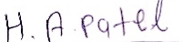

Second Candidate’s Name : SHETH ANAND AJAYKUMAR
Branch : CSE
Enrollment No. : 221430131111
Signature :

Third Candidate’s Name : PATEL NEEL MUKUNDLAL
Branch : CSE
Enrollment No. : 221430131081
Signature :

Fourth Candidate’s Name : PATELBHAGYA NITINKUMAR
Branch : CSE
Enrollment No. : 221430131073
Signature :

Fifth Candidate’s Name : VEDANT MUKESHKUMAR SHAH
Branch : CSE
Enrollment No. : 221430131133

Signature :

Submitted to:
New LJ Institute of Engineering and Technology
Bodakdev, Ahmedabad
ACKNOWLEDGMENT
I cannot express enough thanks to my support members for their continued support and encouragement: Dr Gayatri Pandi (HOD), Prof. Asiya Durani. I offer my sincere appreciation for the learning opportunities to my support members. The completion of this project could not have been accomplished without the support of the team members. A special thanks goes to my team members. They helped me to assemble the parts and gave suggestions about the project.
Besides, we would like to thank all the teachers who helped us by giving us advice and providing the material required. I would like to thank my family and friends for their support. Without that support we couldn’t have succeeded in completing this project. In the end, we would like to thank everyone who helped and motivated us to work on this project.
Thank you all for being part of this experience.

- PATEL HET ASHOKKUMAR
- SHETH ANAND AJAYKUMAR
- PATEL NEEL MUKUNDLAL
- PATEL BHAGYA NITINKUMAR
- VEDANT MUKESHKUMAR SHAH

INDEX

Sr. No. | Topics | Page
 | ABSTRACT | i
 | List of Figures | ii
 | List of Tables | iii
 | ABBREVIATIONS | iv
1. | Introduction | 1
 | 1.1 Project Summary & Profile | 1
 | 1.2 Purpose | 1
 | 1.3 Scope & Objectives | 2
 | 1.4 Technologies | 2
2. | Project Management | 3
 | 2.1 Project Planning | 3
 | 2.1.1 Project Development Approach & Planning | 3
 | 2.1.2 Roles and Responsibilities | 4
 | 2.2 Project Scheduling | 4
 | 2.3 Risk Management | 4
3. | System Requirements Study | 6
 | 3.1 Existing System / Scenario | 6
 | 3.2 Proposed System | 6
 | 3.2.1 Modules & Features in the New System | 6
 | 3.2.2 User Characteristics | 6
 | 3.2.3 Hardware & Software Requirements | 6
 | 3.2.4 Assumptions and Dependencies | 7
4. | System Analysis | 8
 | 4.1 Feasibility Study | 8
 | 4.2 System Activity Diagram | 9
 | 4.3 Use Case Diagram | 12
 | 4.4 Sequence Diagram | 14
5. | System Design | 16
 | 5.1 Database Design/Data Structure Design | 16
 | 5.1.1 ER Diagram | 16
 | 5.1.2 Data Flow Diagram | 18
 | 5.2 Input/output and Interface Design | 20
 | 5.2.1 Flow Chart | 20
6. | Implementation | 22
 | 6.1 Implementation Environment | 22
 | 6.2 Screenshots of Application | 22
 | 6.2.1 Starting Screen | 22
 | 6.2.2 Select of Process screen | 23
 | 6.2.3 Encryption Screen | 23
 | 6.2.4 Decryption Screen | 24
 | 6.3 Sample Coding | 25
 | 6.3.1 Sample Code for Select the Process | 25
 | 6.3.2 Sample Code of Encryption Module | 26
 | 6.3.3 Sample Code of Decryption Module | 27
7. | Testing | 28
 | 7.1 Testing Plan & Strategy | 28
 | 7.2 Testing Methods | 28
 | 7.2.1 Unit Test | 28
 | 7.3 Test Cases | 29
 | 7.3.1 Testing Select the Process Module | 29
 | 7.3.2 Testing Encryption Module | 29
 | 7.3.3 Testing Decryption Module | 30
8. | Limitations and Future Enhancement | 31
 | 8.1 Limitation | 31
 | 8.2 Future Enhancement | 31
9. | Conclusion | 32
10. | References | 33

ABSTRACT
The furniture retail industry is evolving with digital technologies like augmented reality (AR) and artificial intelligence (AI). AR allows customers to visualize how furniture will look in their homes, making online shopping easier and more confident. AI-powered chatbots provide personalized advice and streamline the buying process. IoT devices embedded in furniture help retailers monitor inventory and optimize supply chains. Influencer marketing is also growing, allowing brands to reach wider audiences. These innovations make furniture shopping more convenient, interactive, and reliable, boosting customer satisfaction and confidence. By embracing these technologies, furniture retailers can stay competitive, meet customer expectations, and adapt to the growing demand for digital shopping experiences.

LIST OF FIGURES

Figure No. | Figure Name | Page No.
Fig 1.5.1 | Gantt Chart................................................................................ | 3
Fig 2.1.1 | Activities Canvas....................................................................... | 5
Fig 2.1.2 | Environment Canvas................................................................. | 6
Fig 2.1.3 | Interactions Canvas................................................................... | 8
Fig 2.1.4 | Objects Canvas.......................................................................... | 9
Fig 2.1.5 | Users Canvas............................................................................. | 11
Fig 2.2.1 | Empathy mapping canvas.......................................................... | 13
Fig 2.3.1 | Ideation Canvas......................................................................... | 15
Fig 2.4.1 | Product Development Canvas................................................... | 17
Fig 3.1.1 | Existing System......................................................................... | 20
Fig 3.2.1 | Proposed System....................................................................... | 21
Fig 4.1.1 | DFD Level 0.............................................................................. | 28
Fig 4.1.2 | DFD Level 1.............................................................................. | 29
Fig 4.2.1 | Use Case of the system.............................................................. | 31
Fig 4.3.1 | Class Diagram of the system..................................................... | 33
Fig 4.4.1.1 | ER Diagram of System.............................................................. | 36
Fig 4.5.1 | Activity Diagram of System...................................................... | 40
Fig 4.6.1 | Sequence Diagram of the system.............................................. | 42
Fig.4.7.1 | Flow Chart of the System.......................................................... | 44
Fig.5.1.1 | Detailed System......................................................................... | 45
Fig.5.1.2 | Proposed System-1.................................................................... | 46
Fig.5.1.3 | Proposed System-2.................................................................... | 47
Fig.5.1.4 | Workflow.................................................................................. | 48
Fig.5.3.1 | Proposed System-1.................................................................... | 50
Fig.5.3.2 | Proposed System-2.................................................................... | 50
Fig.5.3.3 | Final System.............................................................................. | 51
Fig. App. B | Business Model Canvas............................................................ | 79

LIST OF TABLE

Table No. | Table Name | Page No.
Table 4.1.1 | DFD Symbol...................................................................... | 27
Table 4.2.1 | Use Case Symbol............................................................... | 30
Table 4.3.1 | Class Diagram Symbols..................................................... | 32
Table 4.4.1.1 | E-R Diagram Symbols…………………………………... | 35
Table 4.4.2.1 | Admin Registration Table................................................. | 37
Table 4.4.2.2 | Vehicle Detail Table.......................................................... | 38
Table 4.4.2.3 | Virtual License Table........................................................ | 38
Table 4.5.1 | Activity Diagram Symbols................................................ | 39
Table 4.6.1 | Sequence Diagram Symbols.............................................. | 41
Table 4.7.1 | Flow Chart Diagram Symbols........................................... | 43

ABBREVIATIONS

UI User Interface
UML Unified Modeling Language
ER Entity Relationship
DFD Data Flow Diagram
GUI Graphical User Interface

CHAPTER-1
INTRODUCTION
  - PROJECT SUMMARY & PROFILE

The Furniture Innovation & Digital Store explores trends in furniture design and digital retail, using AR, VR, and AI for better customer experiences. Case studies highlight successful digital strategies, while interactive features like price calculators and virtual showrooms enhance user engagement. The project equips retailers with tools and insights to thrive in the digital marketplace.

  - PURPOSE

Revolutionize the furniture retail industry by integrating advanced digital technologies. Enhance customer experience through personalized designs and innovative solutions. Promote sustainability in material sourcing and manufacturing processes. Expand market reach and improve efficiency through data-driven insights and digital marketing.

  - SCOPE & OBJECTIVES
Scope:
- Develop a user-friendly digital platform with a virtual showroom and customization tools.
- Collaborate with designers and integrate IoT for innovative designs and supply chain optimization.
- Focus on sustainability in material sourcing and manufacturing, while enabling customer co- creation.
Objectives:
- The project enhances furniture retail by focusing on customer experience, innovation, and sustainability.
- Data analytics guide product development and marketing strategies.
- Digital marketing expands market reach and boosts brand visibility.
- Continuous improvements ensure adaptation to evolving trends and technology.
  - TECHNOLOGIES
- Technology required for develop software
Software: | - MS Visual Studio
 | - Windows Operating system (Version 7+)
Hardware: | - 1.8 GHz or faster processor. Quad-core or better recommended
 | - 2 GB of RAM; 8 GB of RAM recommended (2.5 GB minimum if running on a virtual machine)
 | - Hard disk space: Minimum of 800MB up to 210 GB of available space, depending on features installed; typical installations require 20-50 GB of free space.
 | - Video card that supports a minimum display resolution of 720p (1280 by 720); Visual Studio will work best at a resolution of WXGA (1366 by 768) or higher.

CHAPTER-2
PROJECT MANAGEMENT
  - PROJECT PLANNING
The NextGen Furnishings & Digital Store aims to develop an innovative furniture website featuring 3D models and augmented reality for product visualization. It will include a user-friendly budget mechanism, ensuring seamless navigation and enhanced shopping experiences. A structured development approach, along with rigorous testing, will deliver a reliable platform that meets user needs effectively.

    - Project Development Approach & Planning
The NextGen Furnishings & Digital Store project follows an iterative and milestone-driven approach, focusing on delivering a high-quality digital retail platform for furniture.
Development Phases:
- Research & Conceptualization: Initial research on trends, customer preferences, and competitor analysis shapes feature selection, such as AR-enabled showrooms and AI-driven personalization.
- Feature Design & Prototyping: Wireframes and prototypes are created for key features, focusing on user-friendly navigation and interactive elements like price calculators.
- Technology Stack Selection: Choosing AR and cloud services based on compatibility and performance ensures scalability.
- Agile Development: Using sprints, modules for AR are developed in parallel, with continuous feedback to refine functionality.
- Testing & Quality Assurance: Comprehensive testing, including usability and performance tests, ensures reliability. User feedback during UAT helps fine-tune the platform.
- Deployment & Support: A phased rollout, starting with a beta release, collects user input to inform ongoing updates.

    - Roles and Responsibilities
- Project Manager: Oversees project timelines, resources, and overall progress, ensuring milestones are met and coordinating between team members.
- UI/UX Designer: Designs intuitive interfaces and a user-friendly experience, ensuring consistent design elements across the app.
- Frontend Developer: Builds the app interface using Flutter, implementing the main functionalities like navigation, filtering, and favorites.
- Backend Developer: Manages Firebase setup, integrates authentication, and develops database structures, ensuring smooth data flow and security.
- QA Tester: Conducts testing at each development stage, including functional and usability testing, to ensure the app is stable and performs as expected.

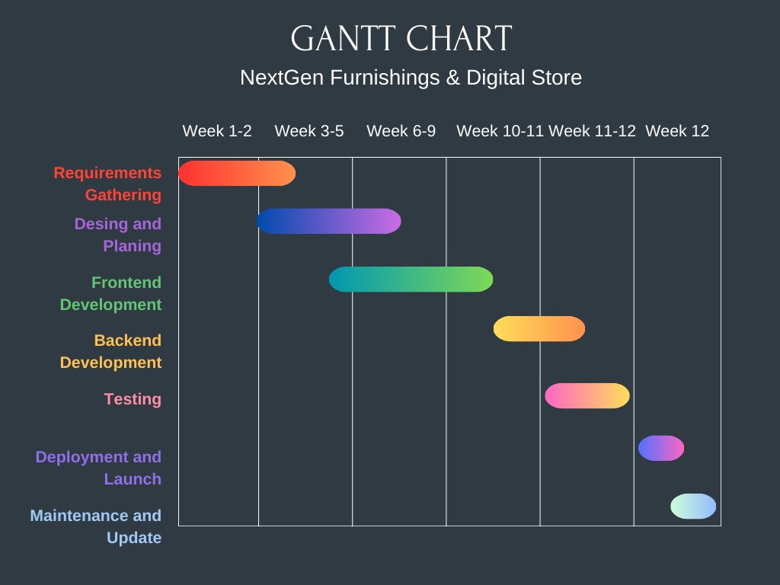
  - Project Scheduling

[Fig 1.5.1]

  - Risk Management
- Technical Risks: Conduct thorough testing to prevent integration issues with 3D modeling tools.
- Resource Risks: Cross-train team members to ensure coverage during personnel shortages and absences.
- Schedule Risks: Implement flexible planning strategies to manage and address potential project delays.
- Budget Risks: Regularly monitor expenses and set aside funds for unexpected costs and overruns. Market Risks: Stay informed about market trends and adapt quickly based on customer feedback.

Risk Identification
Identifying risks early in the development of a furniture e-commerce site, especially one that features 3D models in AR view and a budget mechanism, allows for effective mitigation strategies. Regularly revisiting and updating the risk list as the project progresses helps you stay prepared for potential challenges.
Technical Risks: Data security issues and integration challenges with 3D AR functionality.
Market Risks: Increased competition and changing user preferences affecting sales.
Operational Risks: Development delays and resource availability impacting project progress.
Budget Risks: Unexpected costs and inaccuracies in cost estimates affecting profitability.
Regulatory Risks: Compliance with consumer protection laws and intellectual property concerns Key

Risk Analysis
- Data Security: User data could be compromised during transactions, leading to privacy concerns and potential loss of customer trust.
- Performance Issues: The website may face slow load times or crashes due to high traffic, especially when rendering 3D models, negatively impacting user experience.
- Database Limitations: Potential limits on data storage or query complexity in Firebase could restrict the functionality of features like budget calculations and 3D model interactions.
- User Experience Issue: A complex or unintuitive interface could hinder user engagement, particularly when navigating 3D models or the budget mechanism.
- Compatibility Issues: The website may not perform consistently across all devices or operating systems, leading to a fragmented shopping experience for users.

Risk Planning
- Data Security:
-Use strong encryption, regularly update security protocols, and educate users on safe practices.
- Performance Issues:
- Optimize website performance, conduct load testing, and use CDNs for faster load times.
- Database Limitations:
-Monitor data usage, optimize queries, and consider alternatives if limits impact functionality.
- User Experience Issues:
-Conduct user testing, simplify navigation, and provide guides for using features.
- Compatibility Issues:
-Test across devices, ensure responsive design, and update based on user feedback.
### Monitoring
Regularly review risks and strategies, and gather user feedback to adapt as needed.

CHAPTER-3
SYSTEM REQUIREMENTS STUDY
  - Existing System / Scenario
- User Authentication
  - Registration and secure login/logout.
- Product Catalog
  - Organized categories and search functionality.
- Product Details
  - High-quality images, detailed descriptions, and pricing.
- Shopping Cart
  - Easy item management and quantity adjustments.
- Checkout Process
  - Secure payment options and order summary.
- Contact Page
  - Contact form and company contact information.
- About Us Page
  - Brand story, mission, and team introduction.

  - Proposed System

The proposed furniture website will feature 3D models in augmented reality (AR), allowing users to visualize furniture in their own spaces before purchase. It will include secure user authentication for personalized accounts, a budget mechanism to filter products by price, and a comprehensive category browsing experience. Users can easily save favorite items and utilize a keyword search to find specific products quickly. This approach aims to create a user-friendly and immersive shopping experience that meets diverse customer needs while simplifying the online furniture buying process.

    - Modules & Features in the New System
- User Management Module:
  - Handles user registration, login/logout, profile management, and password recovery.
- Product Catalog Module
  - Displays product listings, allows browsing by categories, and includes detailed product pages with 3D models and AR functionality.
- Shopping Cart Module
  - Manages adding/removing products, updating quantities, and viewing the cart summary.
- Checkout Module
  - Facilitates secure payment processing, order confirmation, and shipping information input.
- Wishlist Module
  - Allows users to save products for future consideration and manage their desired items.

    - User Characteristics

- Home Decor Enthusiasts:
  - Explore various styles to enhance their spaces.
- Busy Professionals:
  - Seek efficient navigation for quick purchases.
- Budget-Conscious Shoppers:
  - Need clear pricing and budget filtering.
- Tech-Savvy Users:
  - Prefer seamless experiences with 3D and AR features.
- Sustainability-Minded Consumers:
  - Look for eco-friendly options and material information.

    - Hardware & Software Requirements

Hardware:
  - Processor: Intel Core i3 or equivalent
  - Memory: 4GB RAM
  - Storage: 128GB SSD or higher
  - Internet Connectivity
Software:
  - Operating System: Windows 10 or macOS Catalina
  - Web Browser: Google Chrome, Mozilla Firefox, Safari
  - Database: MongoDB
  - Development Framework: React.js

    - Assumptions and Dependencies

Assumptions:
- Customer Adoption: It is assumed that customers will be willing to engage with and adopt new digital tools like AR for furniture shopping.
- Technology Integration: The necessary technologies (AR, AI) will integrate smoothly into the Existing systems without significant delays.
- Sustainability Demand: Customers will prioritize and value eco-friendly and sustainable furniture options, driving demand.
- Partnership Support: Strategic partners (designers, tech providers, manufacturers) will actively collaborate and support project goals throughout the development.
Dependencies:
- Technology Providers: The project depends on timely delivery and integration of AR and AI technologies from external vendors.
- Supply Chain Partners: Dependence on sustainable material suppliers and manufacturers for eco- friendly furniture production.
- Customer Engagement: The success of interactive tools like virtual showrooms relies on customer willingness to use and engage with these features.
- Marketing and Sales Teams: The effectiveness of digital marketing strategies and staff training is critical for expanding market reach and ensuring smooth operations.

CHAPTER-4
SYSTEM ANALYSIS
  - Feasibility Study

- Technical Feasibility:
  - Evaluate system requirements (hardware and software)
  - Address scalability (vertical and horizontal)
  - Integrate with payment gateways, shipping providers, and CRM systems Implement security measures and performance optimization

- Operational Feasibility:
  - Assess user acceptance and experience
  - Manage content effectively (product info, promotions)
  - Ensure maintenance and support for functionality and security

- Economic Feasibility:
  - Perform cost-benefit analysis (costs vs. benefits) Conduct risk analysis (financial risks and impacts)

  - System Activity Diagram
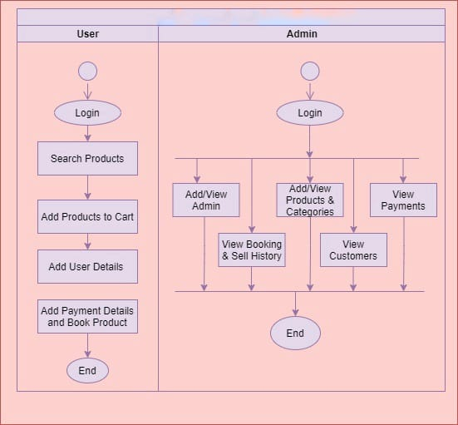
[Fig 4.1.1]
  - Use Case Diagram
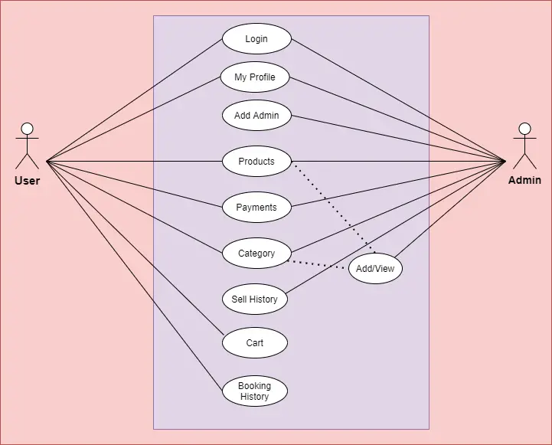
[Fig 4.3.1]
  - Sequence Diagram
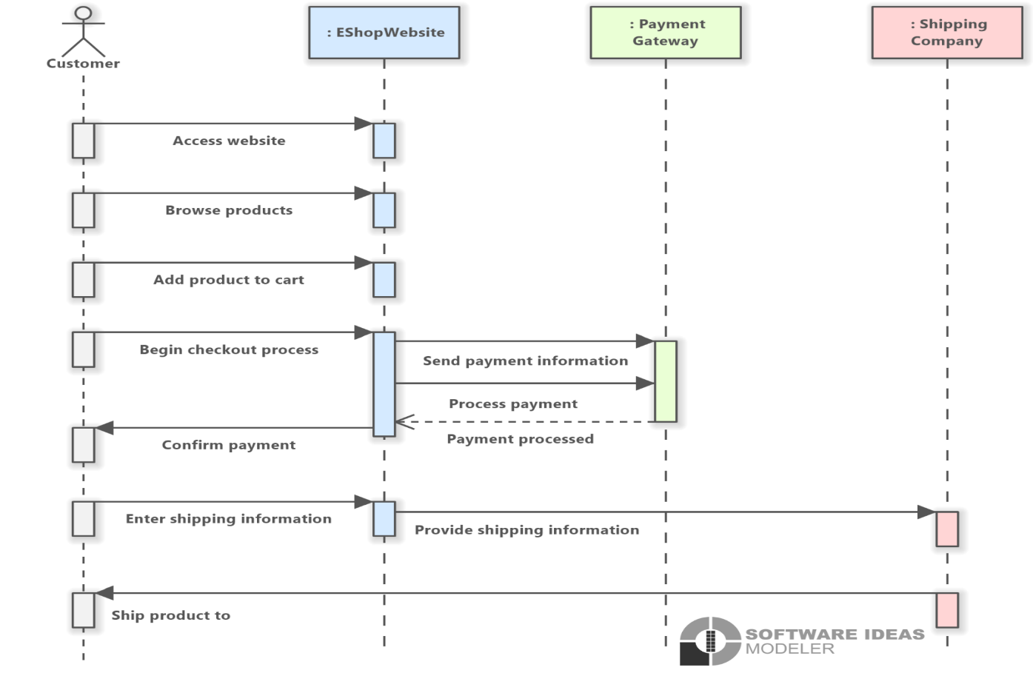
[Fig 4.4.1]

CHAPTER-5
SYSTEM DESIGN
  - Database design
Customers and Products
- Relationship Type: Many-to-Many
- Description: A customer can purchase multiple products, and a product can be bought by multiple customers.
- Implementation: Requires a junction table (e.g., Customer Product or Purchases) to link Customer and Product.
Products and Categories
- Relationship Type: Many-to-One
- Description: A product belongs to a single category, but a category can include multiple products.
- Implementation: Add a foreign key in Product referencing Category.
Customers and Orders
- Relationship Type: One-to-Many
- Description: A customer can place multiple orders, but each order is typically associated with a single customer.
- Implementation: Add a foreign key in Order referencing Customer.
Orders and Products
- Relationship Type: Many-to-Many
- Description: An order can include multiple products, and a product can appear in multiple orders.
- Implementation: Requires a junction table (e.g., Order Product or Order Details) to link Order and Product.
Customers and Reviews
- Relationship Type: One-to-Many
- Description: A customer can leave multiple reviews, but each review is typically written by a single customer.
- Implementation: Add a foreign key in Review referencing Customer.

    - ER Diagram
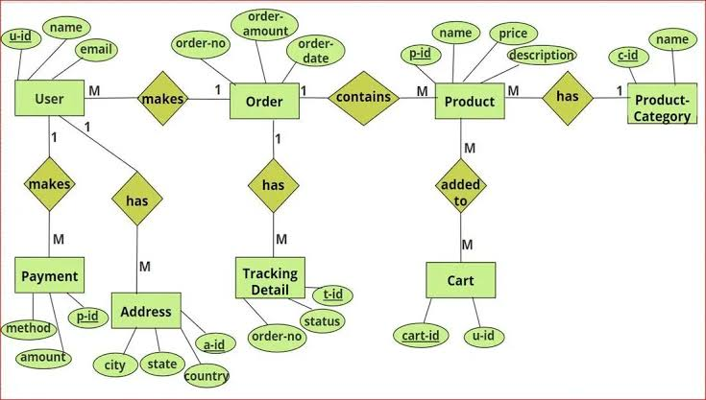
[Fig 5.1.1]
    - Data Flow Diagram
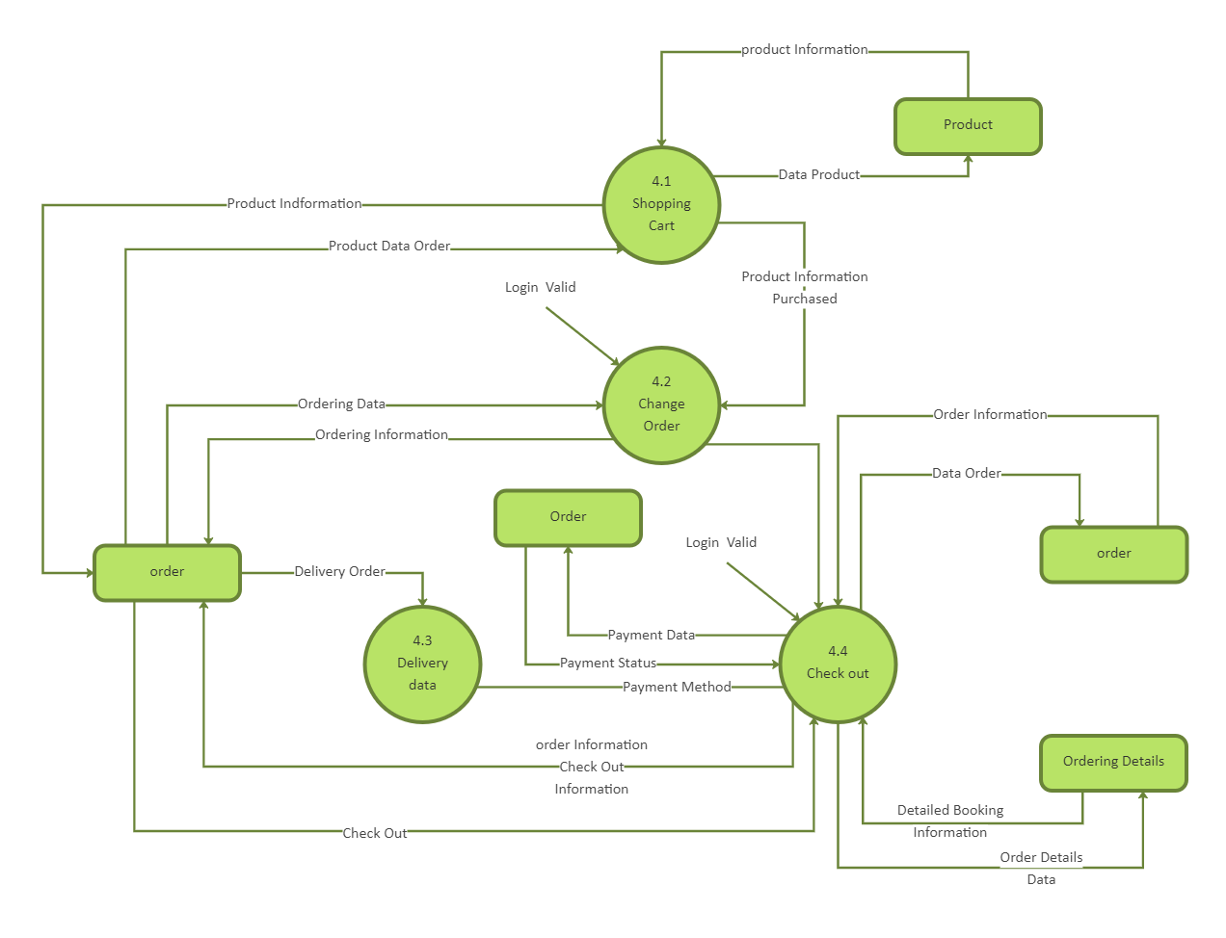
[Fig 5.1.2]

  - Input/output and Interface Design

- The NextGen Furnishing & Digital Store website is designed with a focus on simplicity, responsiveness, and ease of use, leveraging HTML, CSS, and JavaScript to provide an engaging and dynamic shopping experience. Users interact with the website by exploring various product categories, applying customizable filters, marking favorite items, and using a search bar to find specific products. The interface includes intuitive input elements, such as dropdown menus, filter checkboxes, and a search bar, making it easy for users to navigate through a wide array of products.

- Each page output displays products in a visually appealing grid layout, with high-quality images and concise product descriptions. When users apply filters or add items to their Wishlist, the product listings update seamlessly, providing a smooth, real-time experience. The website's layout includes a sticky top navigation bar with quick links to categories and favorites, while a sidebar reveals additional filters for refining searches by product type, material, price range, and brand.

- JavaScript enhances interactivity, handling dynamic features such as search functionality, filter options, and the addition of items to the cart or Wishlist. CSS is used to create a visually appealing design with responsive layouts that adapt gracefully to different screen sizes, ensuring a consistent experience on desktops, tablets, and mobile devices.

- The site’s backend, powered by Firebase, manages tasks like user authentication and real-time data storage, enabling users to save favorite items and view their cart across devices without needing to log in again. Each product card presents an image, price, key specifications, and a button for quick actions like "Add to Cart" or "Add to Wishlist," keeping the shopping experience streamlined and visually engaging. Overall, the design balances aesthetic appeal with functionality, delivering a smooth, responsive, and enjoyable browsing experience for a wide range of user preferences.

    - Flow Chart
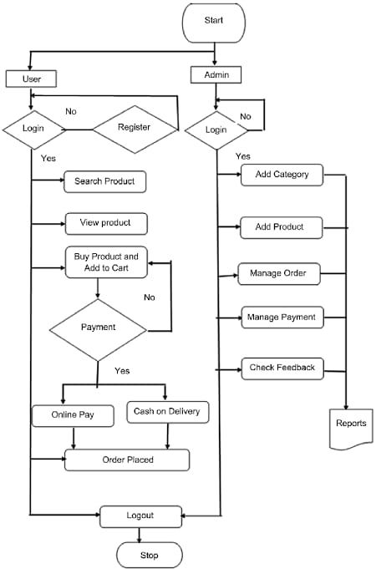

[Fig 5.2.1]

CHAPTER-6
IMPLEMENTATION
  - Implementation Environment
Single-user:
- Designed for individual use.
- Focuses on personal shopping experiences Minimal interaction with other users.

Multi-user:
- Supports interactions among customers administrators, and support staff.
- Enables features like customer reviews, admin dashboards, and user support.

GUI (Graphical User Interface):
- Provides a visual and interactive interface Enhances user experience with graphical elements Makes navigation intuitive and engaging.

Non-GUI:
- Uses text-based interfaces for user interactions.
- Suitable for backend operations or specific environments Less visually engaging but functional for certain use cases.

  - Screenshots of Application
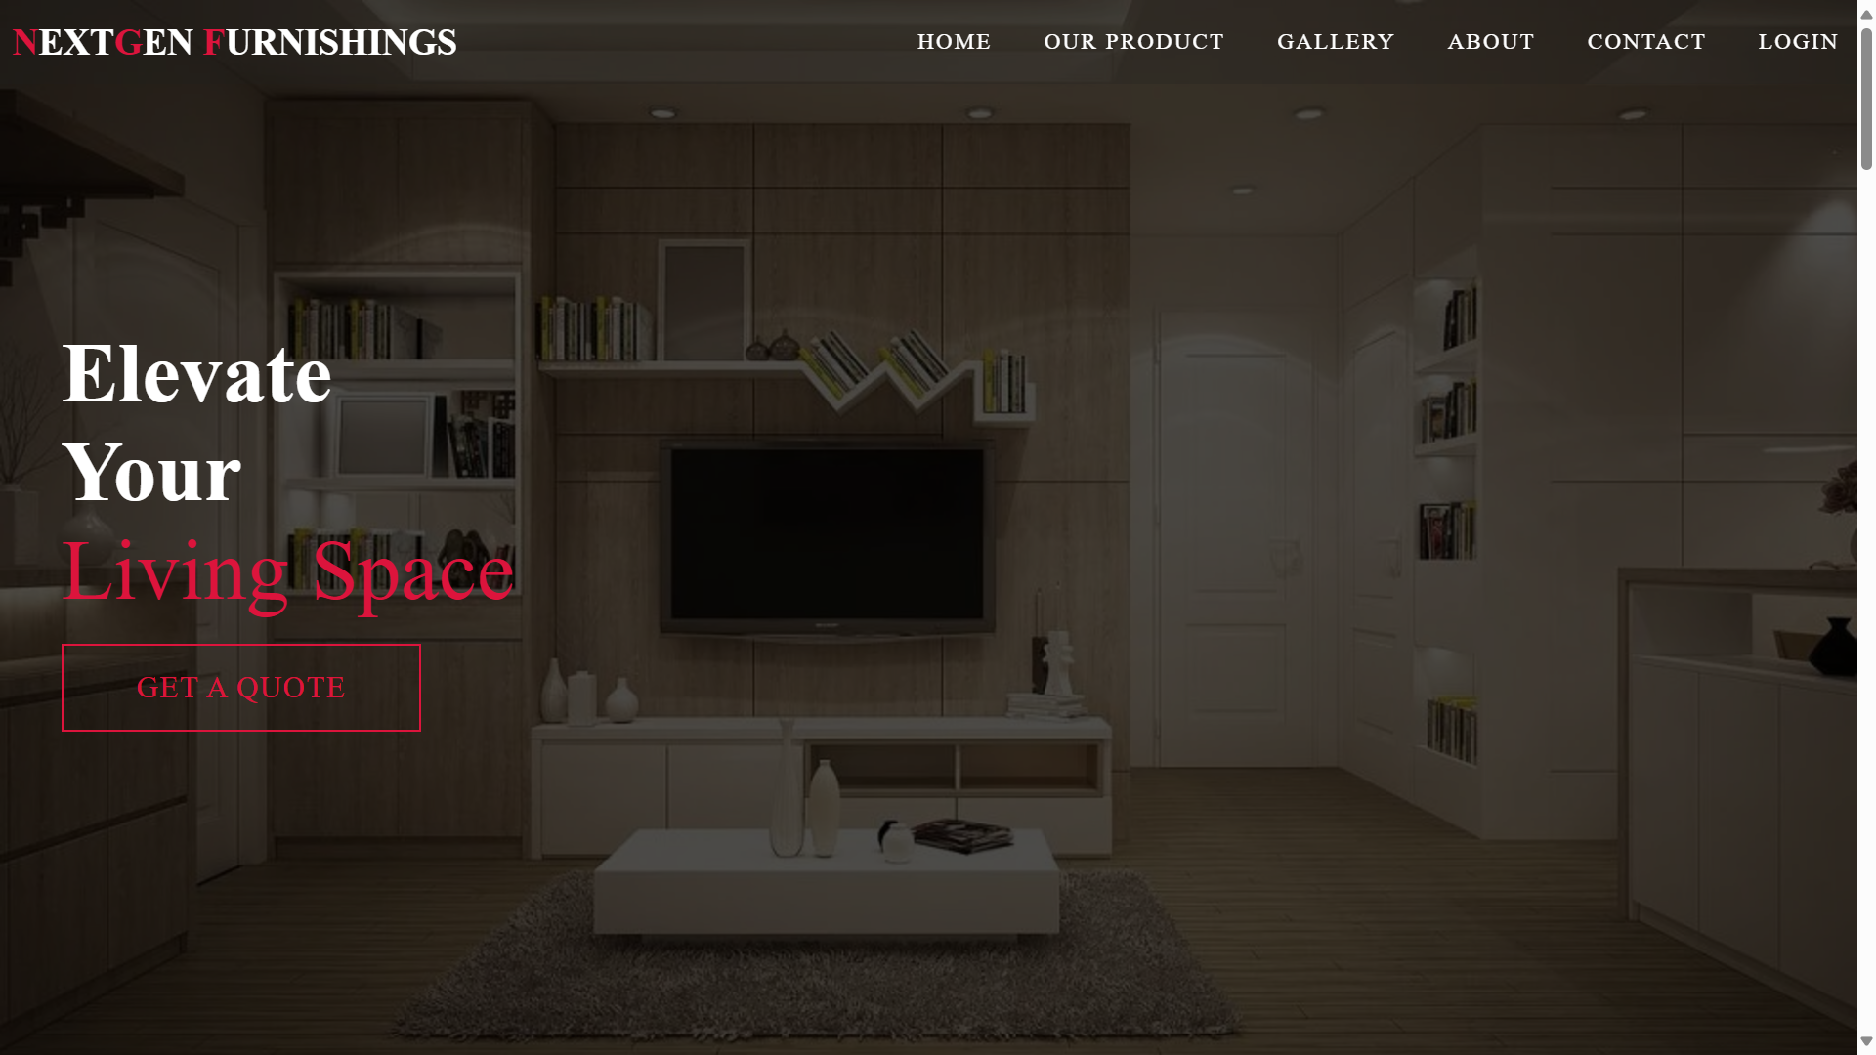

[Fig 6.2.1]

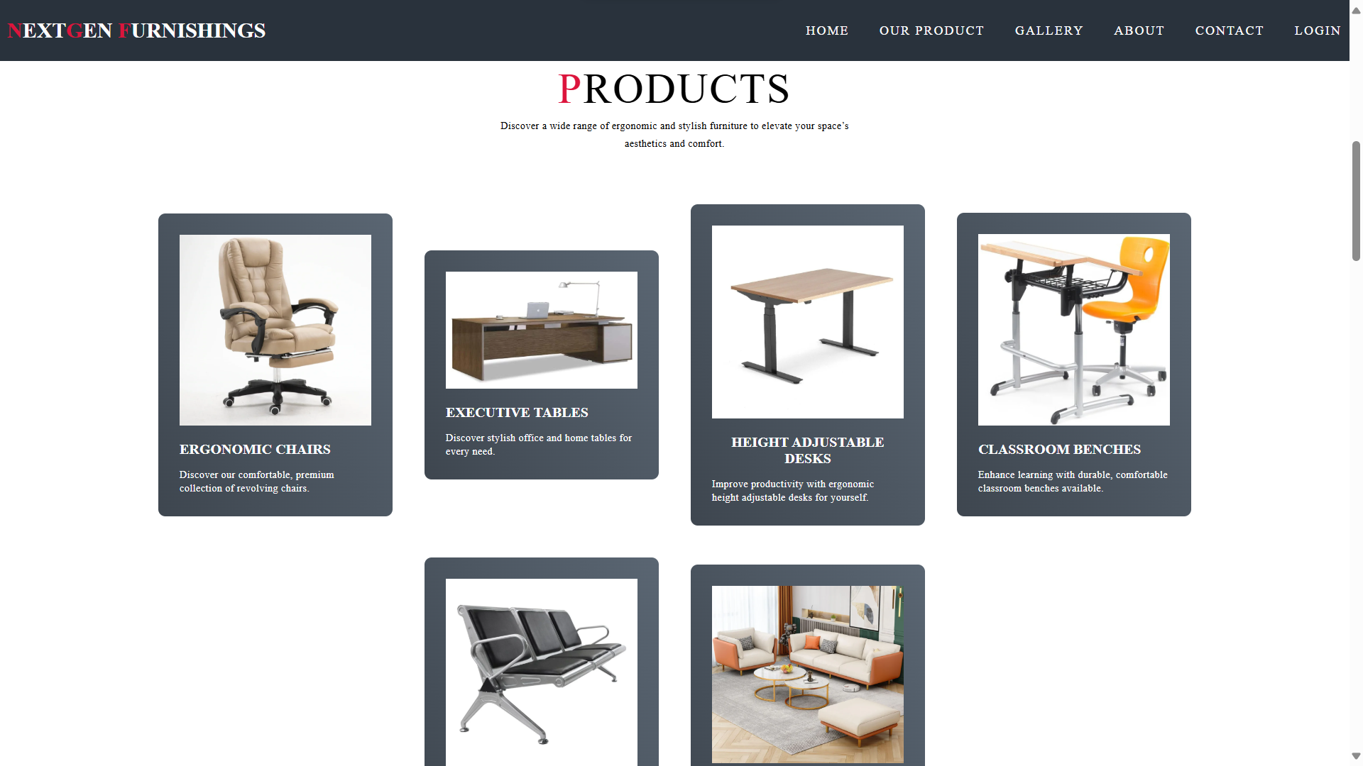

[Fig 6.2.2]

CHAPTER-7
TESTING
  - Testing Plan & Strategy

- The Testing Plan & Strategy for the NextGen Furnishing & Digital Store aims to ensure smooth functionality, usability, security, and performance of the e-commerce website. To achieve these objectives, various testing types will be employed, including functional, usability, performance, security, and compatibility testing.
- Specific test cases will focus on critical user interactions such as product search and filtering, adding items to the cart, the checkout process, order confirmation and tracking, and user account management.
- Execution will involve testing the website in different environments to identify any issues that may arise across various platforms and devices. Resources will be allocated efficiently, and testing phases will be scheduled to cover all aspects of the site. The testing process will be comprehensive, encompassing functional, usability, performance, security, and compatibility assessments to ensure a robust user experience.
- An iterative testing approach will be adopted, allowing for continuous testing and refinement of the website following updates or changes. Additionally, to improve efficiency and accuracy, repetitive tests will be automated, streamlining the testing process and minimizing human error. Overall, this thorough testing strategy guarantees a reliable, secure, and user-friendly e-commerce website that meets the needs and expectations of its users.

- Objectives: Ensure Smooth Functionality, Usability, Security, Performance
- Testing Types: Functional, Usability, Performance, Security, Compatibility
- Test Cases: Product Search and Filtering, Adding Items to the Cart, Checkout Process, Order Confirmation and Tracking, User Account Management
- Execution: Test in Different Environments, Allocate Resources, Schedule Phases
- Process: Functional, Usability, Performance, Security, Compatibility Testing
- Iterative Testing: Continuous testing after updates to refine and enhance the e-commerce website.
- Automation: Automate repetitive tests to improve efficiency and accuracy.
- Conclusion: Thorough testing guarantees a reliable, secure, and user-friendly e-commerce website.

  - Testing Methods

- Functional Testing: Ensure all e-commerce features work as intended.
- Usability Testing: Evaluate user interface and shopping experience.
- Performance Testing: Assess system responsiveness and scalability.
- Security Testing: Identify and address vulnerabilities.
- Compatibility Testing: Verify across browsers and devices.
- Accessibility Testing: Ensure compliance with accessibility standards.
- Load Testing: Measure performance under heavy traffic.

    - Unit Test

- The testing methods for the NextGen Furnishing & Digital Store website ensure optimal performance and user experience. Functional Testing verifies that e-commerce features work correctly, while Usability Testing assesses the site’s intuitiveness and visual appeal. Performance and Load Testing evaluate system responsiveness and its ability to handle high traffic. Security Testing identifies vulnerabilities to protect user information, and Compatibility Testing ensures consistent functionality across different devices. Lastly, Accessibility Testing guarantees compliance with standards for users with disabilities.

  - Test Cases

- The testing plan for the NextGen Furnishing & Digital Store includes a detailed set of test cases to verify the website's core functionality, security, compatibility, and performance. First, Product Search and Filtering will be tested to ensure that users can search for items and apply filters like category, price, and rating, allowing for efficient product browsing. Add to Cart functionality will then be checked, confirming that users can add products to their cart and view updated cart items seamlessly. The Checkout Process test case will focus on ensuring users can complete the purchase journey, from adding items to the cart through to entering payment details and finalizing the order. Following this, an Order Confirmation test will verify that users receive an acknowledgment once a transaction is successfully completed, providing clear details about their purchase.
- Additionally, Order Tracking will be assessed to confirm that users can monitor the status of their orders from their account dashboard. Tests will also cover User Login and Registration, ensuring that both functionalities operate as expected to securely manage user sessions. Compatibility on Different Browsers will be evaluated to guarantee consistent layout and functionality across popular browsers like Chrome, Firefox, Safari, and Edge. Accessibility Compliance testing will verify that the website adheres to accessibility standards, allowing users with disabilities to navigate the site using screen readers and keyboard shortcuts.
- To assess the site’s resilience under heavy traffic, Load Testing will be conducted, checking that the website remains responsive and error-free during high user loads. Security Testing of the payment gateway will verify that transactions are encrypted and secure, safeguarding user data throughout the checkout process. Finally, Cross-Device Compatibility will be tested to ensure the website's layout and functionality are optimized for a range of devices, including desktops, tablets, and mobile phones. These test cases, when combined, provide a comprehensive validation of the website’s reliability, security, and user-friendliness.

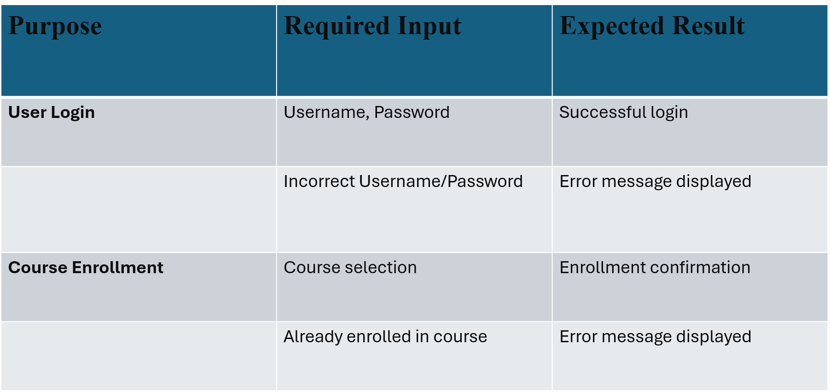

CHAPTER-8
LIMITATIONS AND FUTURE ENHANCEMENT
  - Limitation

- Lack of Customization: While users can location and examine furniture fashions of their real surroundings, there seems to be no point out of customization alternatives (like shade, size, and so on.) restricting the personalization of the purchasing experience.

- Increased Costs and Channel Conflict: Implementing eCommerce through website can be costly. Retailers will have to struggle with this because of the conflict between online sales and brick-and-mortar operations, especially in dealing with shipping and delivery costs.

- Limited Online Sales: While 3D models can simulate a realistic shopping experience, it hasn't significantly boosted online furniture sales. Consumers are hesitant to buy furniture online due to delivery inconveniences and a lack of confidence in purchasing large, costly items without physical interaction.

- Limited User Interaction: Customers might not get direct control over the virtual environment; they relied on the sales assistant for adjustments. This limited their engagement and interaction.

- Data Storage: The application relies on for storing user and product data. 3D models require more robust backend solutions for scalability. It requires a large amount of storage to be loaded

  - Future Enhancement

- Improving Customer Comfort: Adjustments could be made to increase customer comfort during the VR session, such as offering shorter immersive experiences or ensuring a more private and safer environment.

- Incorporating More Sensory Feedback: Expanding the multisensory feedback system (e.g., adding more tactile elements or scents) could make the experience even more immersive.

- Expanding Product Offerings: The VR journey could be expanded to include more diverse product ranges, allowing users to configure a broader selection of items that may not be available in-store Enhanced Model.

- Quality and Realism: Support for more complex, higher-resolution models can be introduced to improve realism, especially with better reflection, texture, and lighting control. This would require enhanced hardware support for real-time rendering of detailed 3D models.

- Offline Functionality: Allowing some offline functionality or downloading selected 3D models for offline use could improve usability in areas with limited connectivity.

CHAPTER-9
CONCLUSION

- In conclusion, implementing 3D visualization and a budget mechanism offers furniture retailers an innovative way to enhance customer experience by enabling realistic product exploration and cost management. Despite high initial costs and the lack of tactile feedback, this approach reduces inventory needs, optimizes store space, and improves customer decision-making, making it a valuable asset for the future of furniture retail.

CHAPTER-10
REFERENCES

- Reference 1: Yoon_VR_furniture-libre.pdf
(d1wqtxts1xzle7.cloudfront.net)

- Reference 2: furnished_an_augmented_reality_based_appr oach_IJERTV10IS050253-libre.pdf
(d1wqtxts1xzle7.cloudfront.net)

- Reference 3: Future Internet | Free Full-Text |
A Multi-Sensory In-Store Virtual Reality Customer Journey for Retailing: A Field Study in a Furniture Flagship Store (mdpi.com)

